Julius Ranoa

CSC 121 001 Computer Science I

Homework – Chapter 10 Pointers

**Programming Challenge @ Page 702.**

Qn. 7 – Movie Statistics.

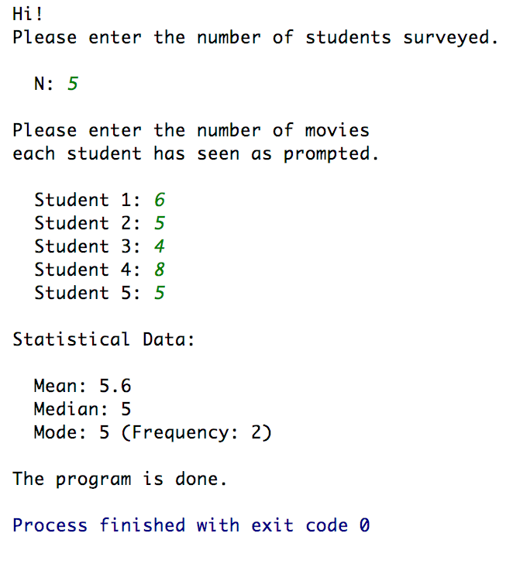

Screenshot of Runtime:

Source Code:

1. *MovieStats.h*
2. *MovieStats.cpp*
3. *main.cpp*

The source code is also stored at Github.

Link below:

<https://github.com/TheLoneWoof1102/FA17_CSC121001/tree/master/Source%20Code/>

**main.cpp**



***// END of main.cpp.***

**MovieStats.h**



***// END of MovieStats.h.***

**MovieStats.cpp**



**// *MovieStats.cpp continued on next page.***

**MovieStats.cpp**

***// END of MovieStats.cpp.***